Middle Ages Tuest – Form A Name_____________________________Date__________Period___
.
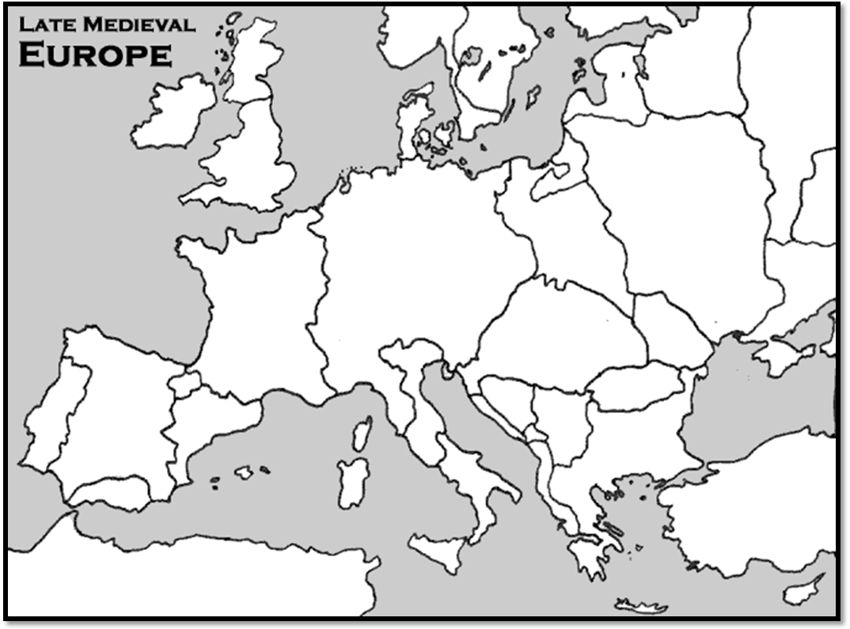
1
2
3
- These groups of invaders settled in Number 1 and filled the power vacuum left by the Roman Empire.
  - Vikings
  - Huns
  - Angles and Saxons
  - Goths

- This group settled in Number 2 and set up a large empire.
  - Visigoths
  - Franks
  - Vandals
  - Ostrogoths

- Number 3 is a city that asked for help from Pope Urban II against attacks from the Muslims.
  - Rome
  - Paris
  - Jerusalem
  - Constantinople

- All of the following are effects of the collapse of the Roman Empire except?
  - Disruption of trade
  - Downfall of cities
  - Loss of common language
  - Increase in education

- What was the outcome of the Battle of Tours?
  - Charles Martel stops the expansion of the Muslim empire into Europe
  - Charlemagne further expanding the Frankish Empire
  - The Crusaders take back Jerusalem from the Muslims
  - The Vikings end the Carolingian dynasty

- Which of the following is a synonym for serf?
  - Monk
  - Noble
  - Peasant
  - Manor

- A tithe was a payment made to which type of person?
  - A lord
  - A vassal
  - A priest
  - A soldier

- Which Crusade was the only successful one for the Christians?
  - First Crusade
  - Second Crusade
  - Third Crusade
  - Fourth Crusade

- The most famous and respected Muslim leader, who create a peace treaty with Christians during the Crusades was:
  - Richard the Lion-hearted
  - Saladin
  - Seljuk
  - Pepin

- The English nobility forced King John to sign the Magna Carta which
  - Gave freedom to all English-born serfs
  - Gave land to the nobles
  - Increased the power of the Church
  - Limited the King’s power

- The Church court used in Spain to persecute Jews and Muslims
  - Bazaars
  - Inquisition
  - Moriscos
  - Convertos

- Who led the French army to victory at Orleans against the English, but was burned at the stake for being a heretic?
  - Charlemagne
  - Pepin
  - Joan of arc
  - John Wycliffe

- The Church built religious communities called
  - Monasteries
  - Manors
  - Castles
  - Universities

- Charlemagne was important in medieval Europe because
  - He stopped the spread of Islam into Spain
  - His invasion of England made it a French colony
  - He established a relatively unified empire in medieval Europe
  - The Catholic Church was unable to control his political actions

- Which member of the feudal system was MOST tied to the land?
  - Blacksmith
  - Farmer
  - King
  - Serf

- The Pope crowning Charlemagne “Holy Roman Emperor” on December 25 in the year 800 CE shows the
  - Effects of Crusades on Western political life
  - Devastation of the Bubonic plague on the Franks
  - Influence of the Church on European government
  - Birth of a new secular era in the Middle Ages

- One long-term effect of the Crusades was the
- Development of Pax Mongolia
- Fall of the Ming Dynasty
- Control of Jerusalem by Europeans
- Growth of trade and towns in western Europe

Base your answers to the following two questions on the speakers’ statements below and on your knowledge of social studies.
Speaker A: We must fight to keep control of Jerusalem in the hands of those who believe in Allah.
Speaker B: Come and battle while there is still time to protect the Holy Land where Christ walked.
Speaker C: We must go forth to heal the split between the churches.
Speaker D: An investment in ships and knights will yield control of profitable trade routes.

- Which speaker expresses a Muslim perspective during the Crusades?
- A
- B
- C
- D

- Which speaker is expressing an economic motive for the Crusades?
- A
- B
- C
- D

- Which heading best completes the partial outline below?

- _____________________________________
  - Escape feudal oppression
  - Earn salvation from sins
  - Recapture the Holy Land
- Goals of the Hanseatic League
- Reasons for Europeans to Fight in the Crusades
- Results of the Reconquista
- Aims of Charlemagne

- What was the most important force in providing unity and stability throughout western Europe during the Middle Ages?
- Church
- Nobility
- Inquisition
- Military

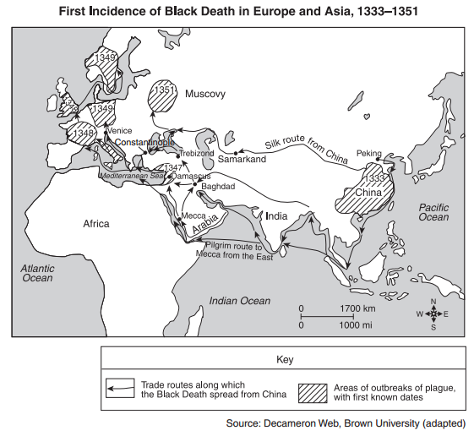
- The information on the above map suggests that the Black Death was primarily spread by the actions of
- Invading armies
- Nomadic peoples
- Merchants
- Explorers

- What is a primary characteristic of a feudal society
- A representative government
- Economic equality for all
- Protection of individual rights
- An exchange of land for services

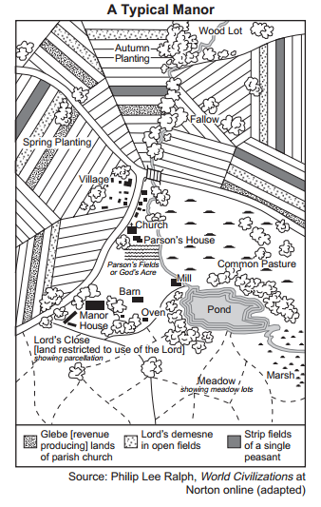
- What does this illustration show about a typical manor?
- All residents were treated equally.
- Secular values in society were stressed.
- There were a large number of factories.
- People depended on agricultural production.

- Which political system is best described in the outline below?

_______________________________
  - Decentralized government
  - Based on loyalty and service
  - Code of chivalry
  - Military elite
- Oligarchy
- Absolutism
- Feudalism
- Democracy

Vocabulary Matching:

1. _______ Fief  2. _______ Vassal  3. _______ Serf  4. _______ Hundred Years War  5. _______ Heresy  6. _______ Crusades  7. _______ Middle Ages  8. _______ Feudalism  9. _______ Lay investiture  10. _______ William the Conqueror | A. Ceremony in which kings and nobles appointed church officials.  B. Period of European history from 500 to 1500  C. Piece of land granted to a vassal from a lord.  D. The main goal of this was to gain control of Jerusalem.  E. Having beliefs or opinions that go against the Church; Joan of Arc was burned at the stake for this.  F. This was fought between England and France over control of land.  G. This person would be given a piece of land in exchange for loyalty and military service.  H. This leader from Normandy took control of England at the Battle of Hastings in 1066.  I. This was the political system in Europe during the Middle Ages in which lords gave land to vassals in exchange for military service and loyalty  J. This person was tied to the land they worked on and often produced agriculture for the manor.

Short Answer:

1. Who had more power in the Middle Ages: the church or kings? Give one example of an event that shows which had one had more power.

2. Discuss three accomplishments of Charlemagne’s rule.

3. How did the introduction of common law under Henry II help to unite England?

Middle Ages Tuest – Form A Name___Answer Key______Date__________Period___
.
1
2
3
- These groups of invaders settled in Number 1 and filled the power vacuum left by the Roman Empire.
  - Vikings
  - Huns
  - Angles and Saxons
  - Goths

- This group settled in Number 2 and set up a large empire.
  - Visigoths
  - Franks
  - Vandals
  - Ostrogoths

- Number 3 is a city that asked for help from Pope Urban II against attacks from the Muslims.
  - Rome
  - Paris
  - Jerusalem
  - Constantinople

- All of the following are effects of the collapse of the Roman Empire except?
  - Disruption of trade
  - Downfall of cities
  - Loss of common language
  - Increase in education

- What was the outcome of the Battle of Tours?
  - Charles Martel stops the expansion of the Muslim empire into Europe
  - Charlemagne further expanding the Frankish Empire
  - The Crusaders take back Jerusalem from the Muslims
  - The Vikings end the Carolingian dynasty

- Which of the following is a synonym for serf?
  - Monk
  - Noble
  - Peasant
  - Manor

- A tithe was a payment made to which type of person?
  - A lord
  - A vassal
  - A priest
  - A soldier

- Which Crusade was the only successful one for the Christians?
  - First Crusade
  - Second Crusade
  - Third Crusade
  - Fourth Crusade

- The most famous and respected Muslim leader, who create a peace treaty with Christians during the Crusades was:
  - Richard the Lion-hearted
  - Saladin
  - Seljuk
  - Pepin

- The English nobility forced King John to sign the Magna Carta which
  - Gave freedom to all English-born serfs
  - Gave land to the nobles
  - Increased the power of the Church
  - Limited the King’s power

- The Church court used in Spain to persecute Jews and Muslims
  - Bazaars
  - Inquisition
  - Moriscos
  - Convertos

- Who led the French army to victory at Orleans against the English, but was burned at the stake for being a heretic?
  - Charlemagne
  - Pepin
  - Joan of arc
  - John Wycliffe

- The Church built religious communities called
  - Monasteries
  - Manors
  - Castles
  - Universities

- Charlemagne was important in medieval Europe because
  - He stopped the spread of Islam into Spain
  - His invasion of England made it a French colony
  - He established a relatively unified empire in medieval Europe
  - The Catholic Church was unable to control his political actions

- Which member of the feudal system was MOST tied to the land?
  - Blacksmith
  - Farmer
  - King
  - Serf

- The Pope crowning Charlemagne “Holy Roman Emperor” on December 25 in the year 800 CE shows the
  - Effects of Crusades on Western political life
  - Devastation of the Bubonic plague on the Franks
  - Influence of the Church on European government
  - Birth of a new secular era in the Middle Ages

- One long-term effect of the Crusades was the
- Development of Pax Mongolia
- Fall of the Ming Dynasty
- Control of Jerusalem by Europeans
- Growth of trade and towns in western Europe

Base your answers to the following two questions on the speakers’ statements below and on your knowledge of social studies.
Speaker A: We must fight to keep control of Jerusalem in the hands of those who believe in Allah.
Speaker B: Come and battle while there is still time to protect the Holy Land where Christ walked.
Speaker C: We must go forth to heal the split between the churches.
Speaker D: An investment in ships and knights will yield control of profitable trade routes.

- Which speaker expresses a Muslim perspective during the Crusades?
- A
- B
- C
- D

- Which speaker is expressing an economic motive for the Crusades?
- A
- B
- C
- D

- Which heading best completes the partial outline below?

- _____________________________________
  - Escape feudal oppression
  - Earn salvation from sins
  - Recapture the Holy Land
- Goals of the Hanseatic League
- Reasons for Europeans to Fight in the Crusades
- Results of the Reconquista
- Aims of Charlemagne

- What was the most important force in providing unity and stability throughout western Europe during the Middle Ages?
- Church
- Nobility
- Inquisition
- Military

- The information on the above map suggests that the Black Death was primarily spread by the actions of
- Invading armies
- Nomadic peoples
- Merchants
- Explorers

- What is a primary characteristic of a feudal society?
- A representative government
- Economic equality for all
- Protection of individual rights
- An exchange of land for services

- What does this illustration show about a typical manor?
- All residents were treated equally.
- Secular values in society were stressed.
- There were a large number of factories.
- People depended on agricultural production.

- Which political system is best described in the outline below?

_______________________________
  - Decentralized government
  - Based on loyalty and service
  - Code of chivalry
  - Military elite
- Oligarchy
- Absolutism
- Feudalism
- Democracy

Vocabulary Matching:

1. ____C___ Fief  2. ___H____ Vassal  3. ____J___ Serf  4. ___F____ Hundred Years War  5. ____E___ Heresy  6. ____D___ Crusades  7. ____B___ Middle Ages  8. ____I___ Feudalism  9. ____A___ Lay investiture  10. ____H___ William the Conqueror | A. Ceremony in which kings and nobles appointed church officials.  B. Period of European history from 500 to 1500  C. Piece of land granted to a vassal from a lord.  D. The main goal of this was to gain control of Jerusalem.  E. Having beliefs or opinions that go against the Church; Joan of Arc was burned at the stake for this.  F. This was fought between England and France over control of land.  G. This person would be given a piece of land in exchange for loyalty and military service.  H. This leader from Normandy took control of England at the Battle of Hastings in 1066.  I. This was the political system in Europe during the Middle Ages in which lords gave land to vassals in exchange for military service and loyalty  J. This person was tied to the land they worked on and often produced agriculture for the manor.

Short Answer:
1. Who had more power in the Middle Ages: the church or kings? Give one example of an event that shows which had one had more power.
Open to student opinion provided they support their answer with a relevant example.
2. Discuss three accomplishments of Charlemagne’s rule.
Open to many possible answers, including creating an Empire, the development of commerce with the use of a unified money system and the building of roads, establishing rules of the feudal system, encouraging the development of knowledge, and of reading and writing.
3. How did the introduction of common law under Henry II help to unite England?
Open to student opinion but they should note that a common law system for England help unify the country because now rules applied to everyone. It created court systems with penalties that people knew and identified with. This helped people feel more unified as a people.

